SATURDAY 28TH JANUARY 2012

UPSTAIRS AT THE LHT URBAN BAR, WHITECHAPEL, LONDON E1
Opposite Whitechapel Tube & Overground station, next door to The Royal London Hospital

PROUDLY PRESENTS……

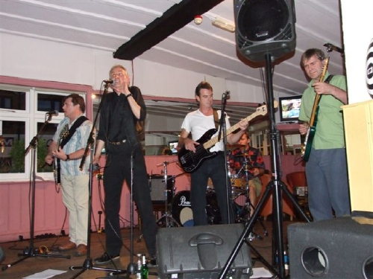
THE CATALINA BLUES BAND

Maximum Rhythm & Blues

Doors Open at 8pm Fundraiser Entry £7
Plus Raffle & Late Bar



All proceeds to www.musicfundforcuba.org.uk

